Odd and Even Numbers - Questions

Key Stage 2: 2004 Paper A
1.
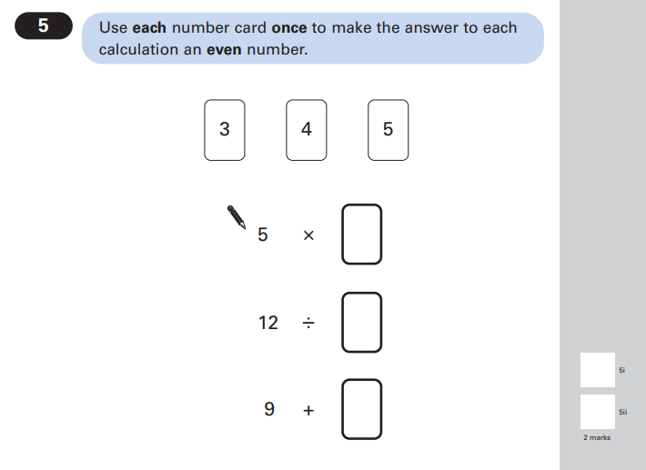

Key Stage 2: 2004 Paper A
2.
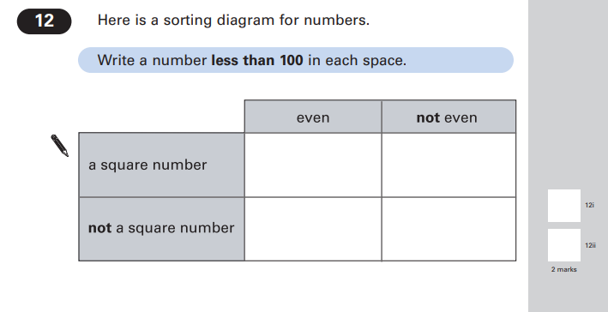
Key Stage 2: 2004 Paper A
3.

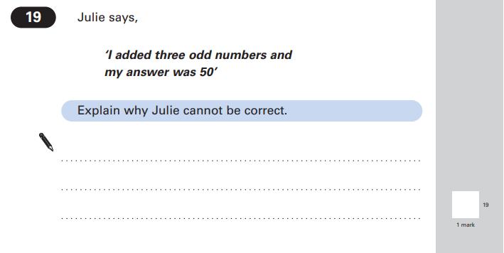

Key Stage 2: 2008 Paper B
1.
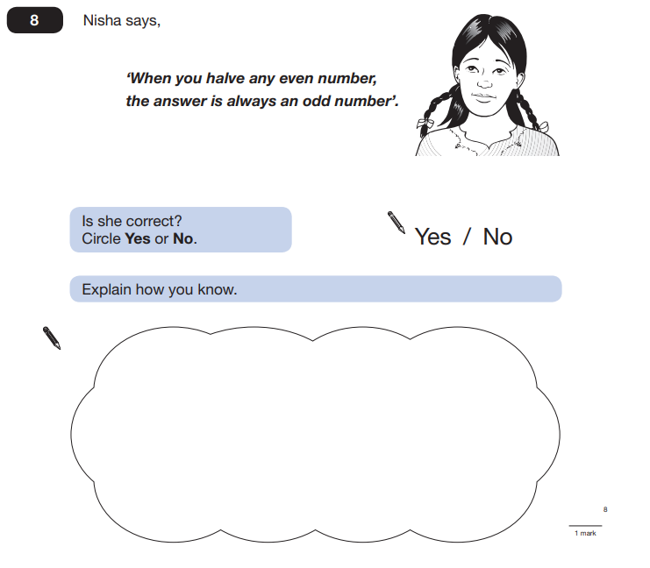

Key Stage 2: 2008 Paper B
2.
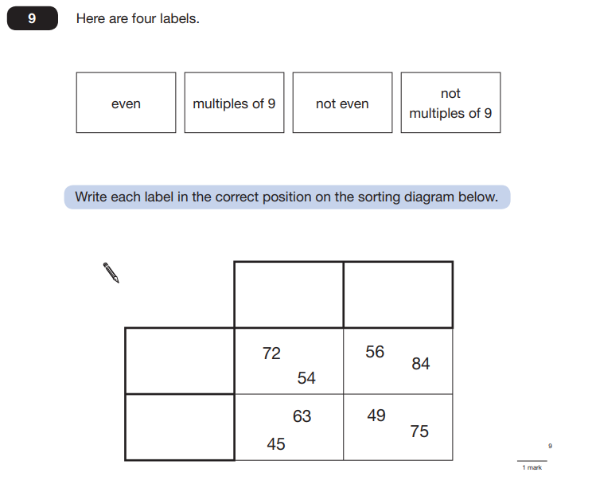

Key Stage 2: 2010 Paper A
1.
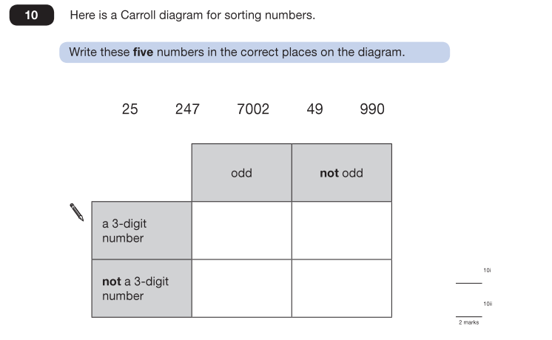
Key Stage 2: 2010 Paper A
2.
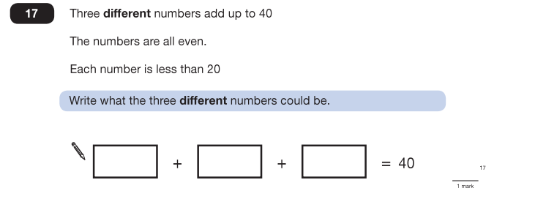

Key Stage 2: 2011 Paper A
1.
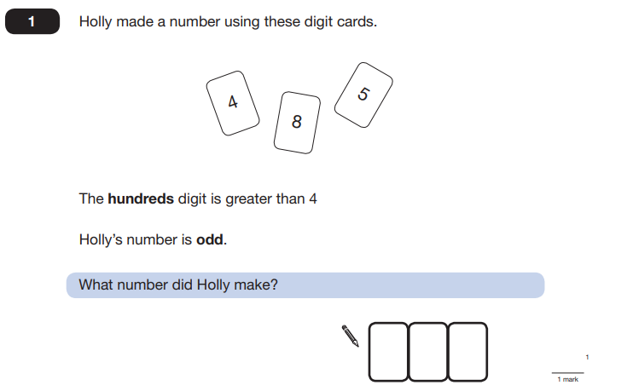

Key Stage 2: 2012 Paper B
1.
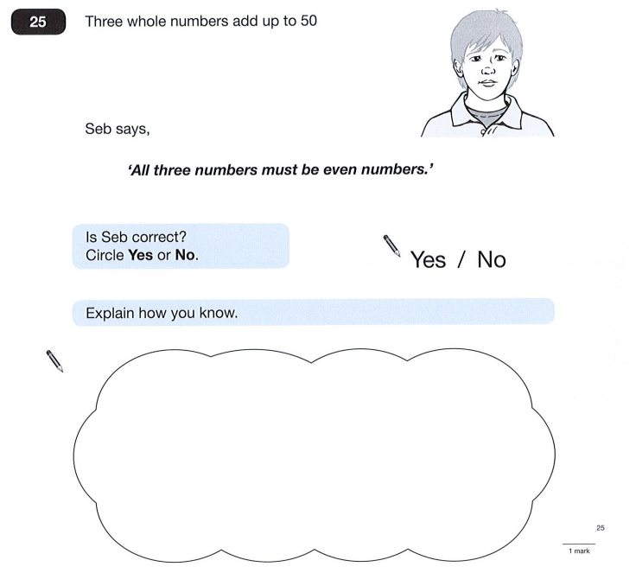

Key Stage 2: 2013 Paper B L6
1.
